**Load Balancer**

*App1-----websites on 8000 App2-----websites on 9500*

*---wesbites on 9000 ---wesbites on 9800*

Then we search on browser on base machine i.e chrome-----reverse.NAT-IP/App1

(192.168.15.161) /App2

Go to window server machine and create webpages

Drive C--🡪inetpub🡪create 2 folders i.e

App1🡪create 2 folder web1🡪create index.html and web2🡪 create index.html && App2🡪create 2 folder web3🡪create index.html and web4🡪 create index.html

Then go to server manager🡪tools🡪iis services🡪drop down win4 on left side🡪sites will appear🡪right click on sites🡪add websites as shown below:--

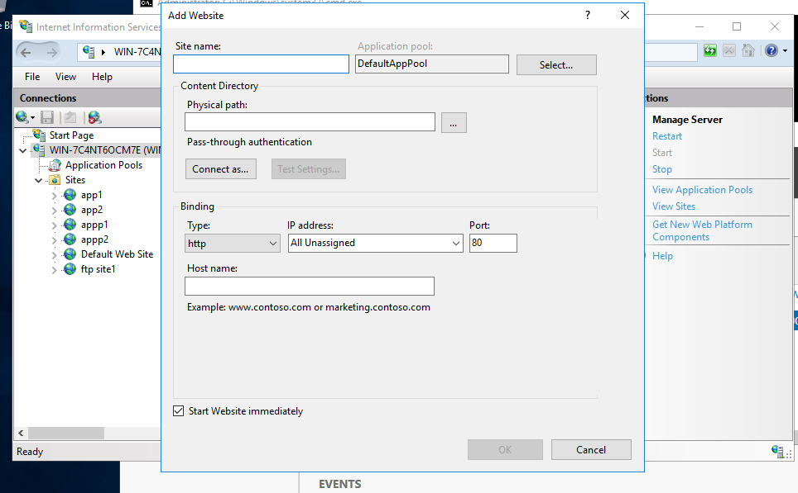

* [root@server ~]# cd /etc/nginx/
* [root@server nginx]# vim nginx.conf
* [root@server nginx]# systemctl restart nginx.service
* [root@server nginx]# cat nginx.conf
* # For more information on configuration, see:
* # * Official English Documentation: http://nginx.org/en/docs/
* # * Official Russian Documentation: http://nginx.org/ru/docs/
* user nginx;
* worker_processes auto;
* error_log /var/log/nginx/error.log;
* pid /run/nginx.pid;
* # Load dynamic modules. See /usr/share/doc/nginx/README.dynamic.
* include /usr/share/nginx/modules/*.conf;
* events {
* worker_connections 1024;
* }
* http {
* log_format main '$remote_addr - $remote_user [$time_local] "$request" '
* '$status $body_bytes_sent "$http_referer" '
* '"$http_user_agent" "$http_x_forwarded_for"';
* access_log /var/log/nginx/access.log main;
* sendfile on;
* tcp_nopush on;
* tcp_nodelay on;
* keepalive_timeout 65;
* types_hash_max_size 4096;
* include /etc/nginx/mime.types;
* default_type application/octet-stream;
* # Load modular configuration files from the /etc/nginx/conf.d directory.
* # See http://nginx.org/en/docs/ngx_core_module.html#include
* # for more information.
* include /etc/nginx/conf.d/*.conf;
* **upstream app1 {**
* **server 10.10.10.133:8000;**
* **server 10.10.10.133:9000;**
* **}**
* **upstream app2 {**
* **server 10.10.10.133:9500;**
* **server 10.10.10.133:9800;**
* **}**
* server {
* listen 80;
* listen [::]:80;
* server_name _;
* root /usr/share/nginx/html;
* # Load configuration files for the default server block.
* include /etc/nginx/default.d/*.conf;
* **location /app1{**
* **proxy_pass http://app1/;**
* **}**
* **location /app2 {**
* **proxy_pass http://app2/;**
* **}**
* error_page 404 /404.html;
* location = /404.html {
* }
* error_page 500 502 503 504 /50x.html;
* location = /50x.html {
* }
* # location /{
* # proxy_pass http://localhost/;
* # }
* # location /acts {
* # proxy_pass http://10.10.10.133:8000/;
* # }
* # location /hpcsa {
* # proxy_pass http://10.10.10.133:9000/;
* # }
* # location /ditiss {
* # proxy_pass http://10.10.10.133:9500/;
* # }
* }
* # Settings for a TLS enabled server.
* #
* # server {
* # listen 443 ssl http2;
* # listen [::]:443 ssl http2;
* # server_name _;
* # root /usr/share/nginx/html;
* #
* # ssl_certificate "/etc/pki/nginx/server.crt";
* # ssl_certificate_key "/etc/pki/nginx/private/server.key";
* # ssl_session_cache shared:SSL:1m;
* # ssl_session_timeout 10m;
* # ssl_ciphers HIGH:!aNULL:!MD5;
* # ssl_prefer_server_ciphers on;
* #
* # # Load configuration files for the default server block.
* # include /etc/nginx/default.d/*.conf;
* #
* # error_page 404 /404.html;
* # location = /40x.html {
* # }
* #
* # error_page 500 502 503 504 /50x.html;
* # location = /50x.html {
* # }
* # }
* }
* [root@server nginx]#

OUTPUT OF LOAD BALANCER(APP1)

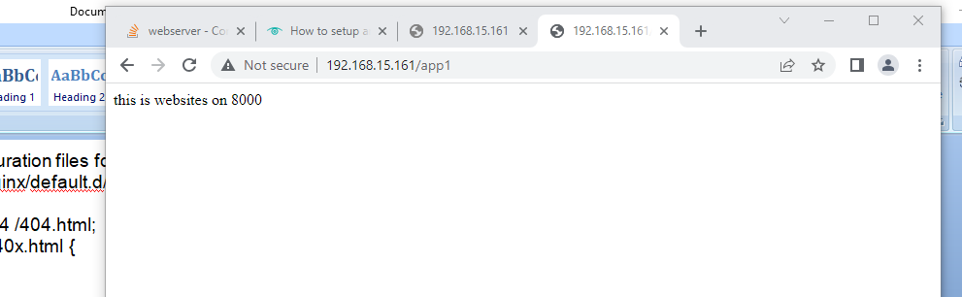

After refresing the page it will show the next port webpage

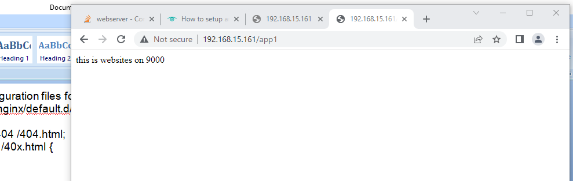

OUTPUT OF LOAD BALANCER(APP2)



After refresing the page it will show the next port webpage

